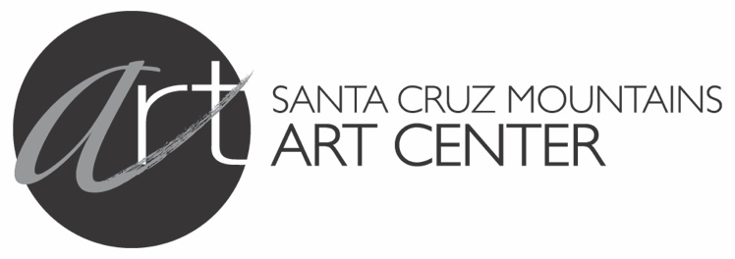
______________________________________________________________________________________________________
Featured Artists Application
Please read the entire Prospectus, then fill out this application and email to info@MountainArtCenter.org with Featured Artist in the subject line. Accompany the application with 3 examples of the work you will exhibit in the
show. These must be in jpg format at 300 dpi.
Name: ______________________________________________________________________________________
Address: _____________________________________________________________________________________
City: _____________________________________________________ State: _______ Zip: _________________
Email: ____________________________________________________ Phone: ____________________________
❑ Check here if you plan to show as a solo artist.
Or, list the other artist(s) (up to three) you plan to show with.
Each artist must also submit their own application form.
1. ___________________________________________________________________________________________
2. ___________________________________________________________________________________________
3. ___________________________________________________________________________________________
Please list the 6 examples of your work that you will be submitting with your application:
1. Title: ___________________________________________________ Year Created: ______________________
Medium: ________________________________________________ Size: ______________________________
2. Title: ___________________________________________________ Year Created: ______________________
Medium: ________________________________________________ Size: ______________________________
3. Title: ___________________________________________________ Year Created: ______________________
Medium: ________________________________________________ Size: ______________________________
Artists accepted for shows automatically allow the Santa Cruz Mountains Art Center to use images for publicity purposes.
❑ I have read and agree to the terms and conditions of the Featured Artist Prospectus.
Signature: __________________________________________________ Date: _____________________________
________________________________________________________________________________________________________
Santa Cruz Mountains Art Center 9341 Mill Street Ben Lomond, Ca 95005 831-336-3513 www.MountainArtCenter.org

